Asian C-License Referees Exam Info

Asian C-License Referees Exam
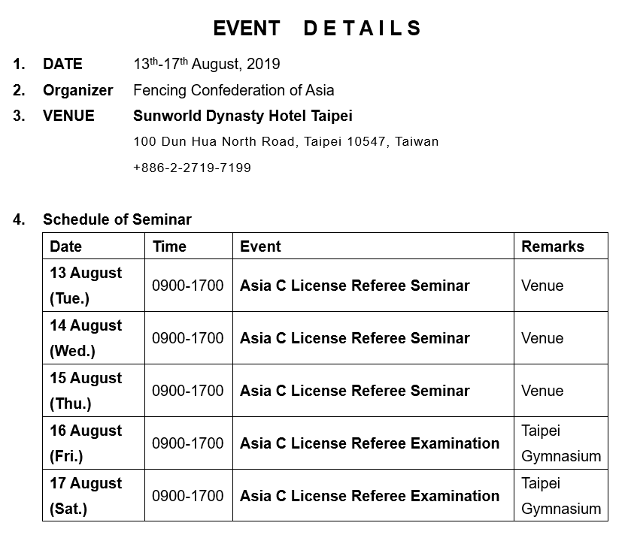

*Reminder:
- All fees including registration, accommodation, and transportation fees will be collected on the first day of each seminar/exam.
- The daily schedule has been finalized as follows:
• August 13, 2019 ​9 to 11 am​ EPEE seminar, followed by the Video exam
• August 14, 2019​ 9 to 11 am ​FOIL seminar, followed by the Video exam
• August 15, 2019​ 9 to 11 am ​SABER seminar, followed by the Video exam
• August 16, 2019​ Practical Exam for EPEE and FOIL from 9 am onwards
• August 17, 2019​ Practical Exam for SABER from 9 am onwards

