FCA INFORMATION BULLETIN No. 5-2020
June 4, 2020

FCA GENERAL ASSEMBLY AND ELECTIONS

As you may know, the FCA General Assembly and Elections is originally scheduled for October 13 in Taipei, immediately before the Asian Under-23 Championships. Considering however the prevailing conditions brought about by the COVID-19 pandemic, we are not yet certain that the situation at that time will allow all the delegates to travel and for us to hold the meeting in normal conditions.

Upon consultation with the FIE, we were advised to refrain from making any decision prematurely. At a more appropriate time, we hope to decide how to proceed with the General Assembly and Elections. Obviously, there is a need to deviate from some of the provisions of the FCA Constitution considering the abnormality of the situation we are in right now. For this reason we decided first to cancel the AU23 so as not to keep our athletes in suspense as to what to expect, while we defer decision on the FCA General Assembly.

CANCELLATION OF OTHER FCA COMPETITIONS

Considering the ongoing COVID-19 pandemic that has affected the whole world, most countries are still in lockdown, with international flights cancelled and travel restrictions still in place. Most of our athletes were forced to stop training and any local or international competitions can’t be scheduled with any certainty.

In view of this, the FCA Executive Board recently decided to definitely cancel two more competitions in Asia, namely 1) the Asian Juniors and Cadets Fencing Championship which was postponed from the February schedule in Jakarta Indonesia, and 2) the Asian Under-23 Fencing Championships which is scheduled to be held in Taipei on October 14-19, 2020.

Effectively therefore, the ongoing Covid-19 pandemic has already forced the cancellation of the following FCA competitions for 2020:

- The Asian Juniors and Cadets Fencing Championships (in Indonesia)
- The Asian (seniors) Fencing Championships and Olympic Qualifiers (in Korea)
- The Asian Veterans Fencing Championships (in Hong Kong)
- The Asian Under 23 Fencing Championships (in Taipei)

Please understand that in these decisions, the interests and safety of our fencers were upmost in our mind.

COMPETITION SCHEDULES FOR 2021

While we can only assume at this time that the situation is normalized in 2021 for all of us to resume competitions, the FCA Executive Board recently decided to plan out our calendar for 2021. In doing so however, the Board gave due consideration to the preparations and investments that the 2020 host federations (from Indonesia, Korea, Hong Kong, and Taipei) had already put in these competitions but were forced to abruptly stop because of this pandemic.

Moving forward therefore, the host federations of the following competitions in 2021 have been approved.

- The 2021 Asian Juniors and Cadets Fencing Championships. Since the All Indonesia Fencing Association (AIFA) expects that their government may still not allow sports competitions by early 2021, AIFA requested to avail of their hosting rights in 2022 (but preferably the AFC). Accordingly, our Board re-confirmed its previous approval granting Fencing Federation of UZBEKISTAN the right to host the 2021 AJCFC.

- The 2021 Asian Fencing Championships and Olympic Qualifiers. While Saudi Arabia was already approved to host the AFC in June 2021, this grant could not be realized since the postponement of the Tokyo Olympics also changed the dates of our Olympic Qualifier to April 2021 in conjunction with the 2021 AFC. Considering however the preparations already made by the KFF and the subsidies already given to many federations to travel to Korea, our Board decided to allow the Korean Fencing Federation to host the Olympic Qualifiers and Asian Fencing Championships within April 15-30, 2021 (as prescribed by the FIE).

- The 2021 Asian Veterans Fencing Championships. Since the 2021 AVFC host has not yet been assigned, our Board again granted the Hong Kong Fencing Association the right to host the 2021 Asian Veterans Fencing Championships

- The 2021 Asian Under-23 Fencing Championships. Though the CTFA claims that Covid-19 is under-control in Taiwan, the uncertainties prevailing in other countries led to our cancellation on the AU23 this year. The FCA Executive Board therefore decided to again grant the Chinese Taipei Fencing Association the right to host the 2021 Asian Under-23 Fencing Championships (in lieu of Kuwait which will be moved to 2022).

2022 COMPETITIONS

Considering the above decisions regarding our 2021 FCA competitions, our Board has also agreed on the following:

- Grant to KUWAIT the right to host the 2022 Asian Under-23 Fencing Championships, and

- Consult with the fencing federations of INDONESIA and SAUDI ARABIA to decide on the hosts of the 2022 Asian Juniors and Cadets Fencing Championships (AJCFC) and the 2022 Asian Fencing Championships (AFC), which will be reserved for these two federations.

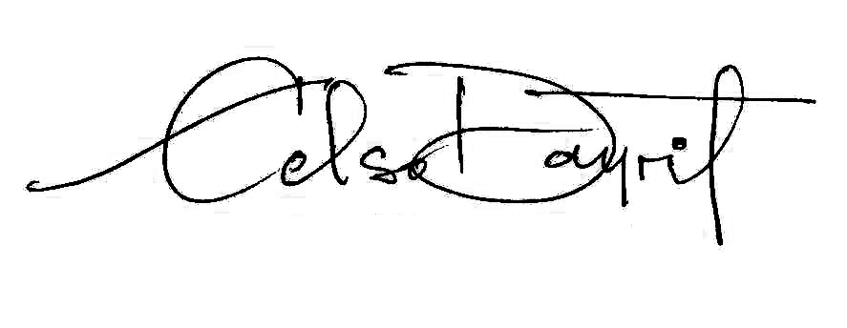
Sincerely yours

CELSO L. DAYRIT
President

