FCA INFORMATION BULLETIN No. 4 – 2020
May 03, 2020

TOKYO 2020 OLYMPIC GAMES

You may already know by now that the International Olympic Committee has decided to postpone the Tokyo 2020 Olympic Games to be held in its new schedule starting on July 23, 2021 until August 8, 2021. The IOC together with all stakeholders and the Japanese organizers are working to ensure the success of the Games next year, barring of course the threat of the current COVID-19 pandemic.

In this connection, the International Fencing Federation will also have to re-study its new calendar leading to the Games in 2021, to include the various Olympic Qualifying events and other relevant international competitions. As soon as the situation will permit, the FIE and the FCA will announce any decision with regards our future calendar of events.

OLYMPIC QUALIFIERS and ASIAN FENCING CHAMPIONSHIPS

Because of the uncertainties brought about by the current pandemic, the FIE has cancelled all Olympic Qualifiers and Zonal senior Championships for this year in all continents. Therefore, the Olympic Qualifiers and Asian Fencing Championships which was supposed to be held in Seoul Korea in April 15 to 22, 2020, is thus cancelled, and not postponed as stated in our previous Information Bulletin No. 3-2020.

Correspondingly, these two events which are relevant for the Tokyo Olympic Games will be scheduled for early 2021.

CANCELLATION OF MORE FCA EVENTS IN 2020

In view of the continuing uncertainties brought about by the COVID-19 pandemic which has put most countries in the world under lockdown, prohibition on mass gatherings, quarantine protocols and travel restrictions, the following competitions scheduled for the third quarter of 2020 will be cancelled:

- All the scheduled competitions under the Asian Cadet Circuit for season 2020-2021. In the calendar, the affected Cadet Circuit competitions starting in July until September are in the Philippines, Singapore, China, Taiwan, Japan, Jordan, Malaysia and Kuwait.

- The 2020 Asian Veterans Fencing Championships scheduled in Hong Kong this September. Upon request of the Hong Kong Fencing Association, the FCA agreed to cancel this event, which would have seen the participation of veteran fencers (considered as the most vulnerable sector of society). Nonetheless, the HKFA has signified their willingness to organize the AVFC in 2021, should the health situation permit.

2021 ASIAN YOUTH GAMES

In the calendar of events of the Olympic Council of Asia, the 3rd edition of the Asian Youth Games is scheduled to be held in Shantou China on November 20 to 28, 2021. This quadrennial competition was supposed to have been held in Surabaya Indonesia in 2017, but because of the 2018 Asian Games that were in Jakarta, the AYG in 2017 was cancelled. The 2nd AYG were held in Nanjing China in 2013, while the inaugural AYG was celebrated in Singapore in 2009.

Unfortunately, we recently learned that our sport of Fencing is not in the program of the 2021 AYG which was decided by the Olympic Council of Asia last year. Nonetheless, I already made our official representation with the OCA and together with the assistance of President Wang Haibin of the Chinese Fencing Association, the Chinese Olympic Committee and the local organizers of the 2021 AYG have committed to fully support our request.

Fencing was included and widely participated in during the 2013 AYG in Nanjing, though our sport missed the first edition in Singapore which included only a minimum number of sports.

2021 WORLD UNIVERSITY GAMES

It is of interest for all of us to know that the next World University Games are scheduled for August 18 to 29, 2021 in Chengdu China. This schedule was made before the outbreak of COVID-19 pandemic which now has caused a lot of disruption in the world of sports, like the postponement of the Tokyo Olympic Games which is now re-scheduled for July 23 to August 8, 2021.

As our sport of Fencing has always been in the programme of all previous World University Games or commonly referred to as the UNIVERSIADE, the new schedule of the Olympic Games will cause major concerns since many of the participants in this “high-level” competition are likewise competitors in the Olympic Games

We will wait for further announcement from the Federation Internationale du Sport Universitaire (FISU) which is the responsible and world governing body in charge of this competition for student-athletes between the ages of 17 and 28.

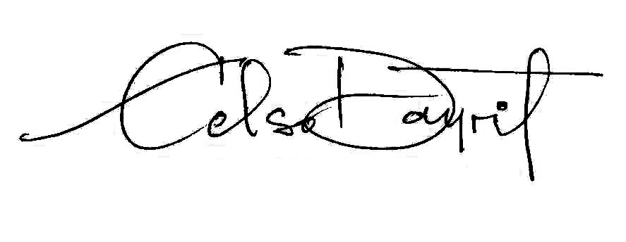

Dr. CELSO L. DAYRIT
President

