Competition Management Seminar Info

Competition Management Seminar
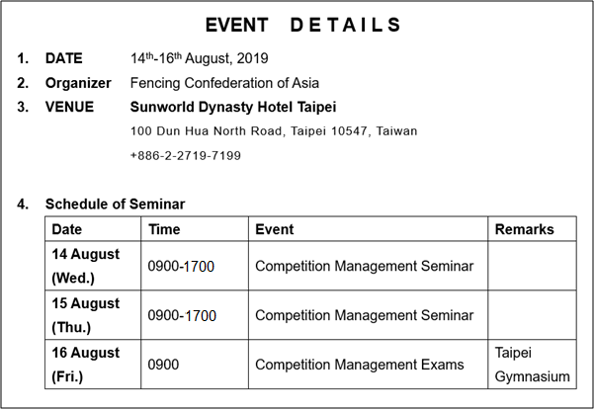

*Reminder:
- All fees including registration, accommodation, and transportation fees will be collected on the first day of each seminar/exam.
- The daily schedule has been finalized as follows:
Day 1:
A.M. Competition Management in General - Marilee
P.M. D.T. Duties and Responsibilities - Abbas
Day 2: Results Management (Fencing Time) (whole day) - Dan Berke
Day 3: Asian Veterans Fencing Championships (shadowing)
- The examinee should bring their own laptop with them on Day 2 and Day 3. Kindly note that Fencing time doesn't have a Mac version so their computer should have Microsoft OS.

