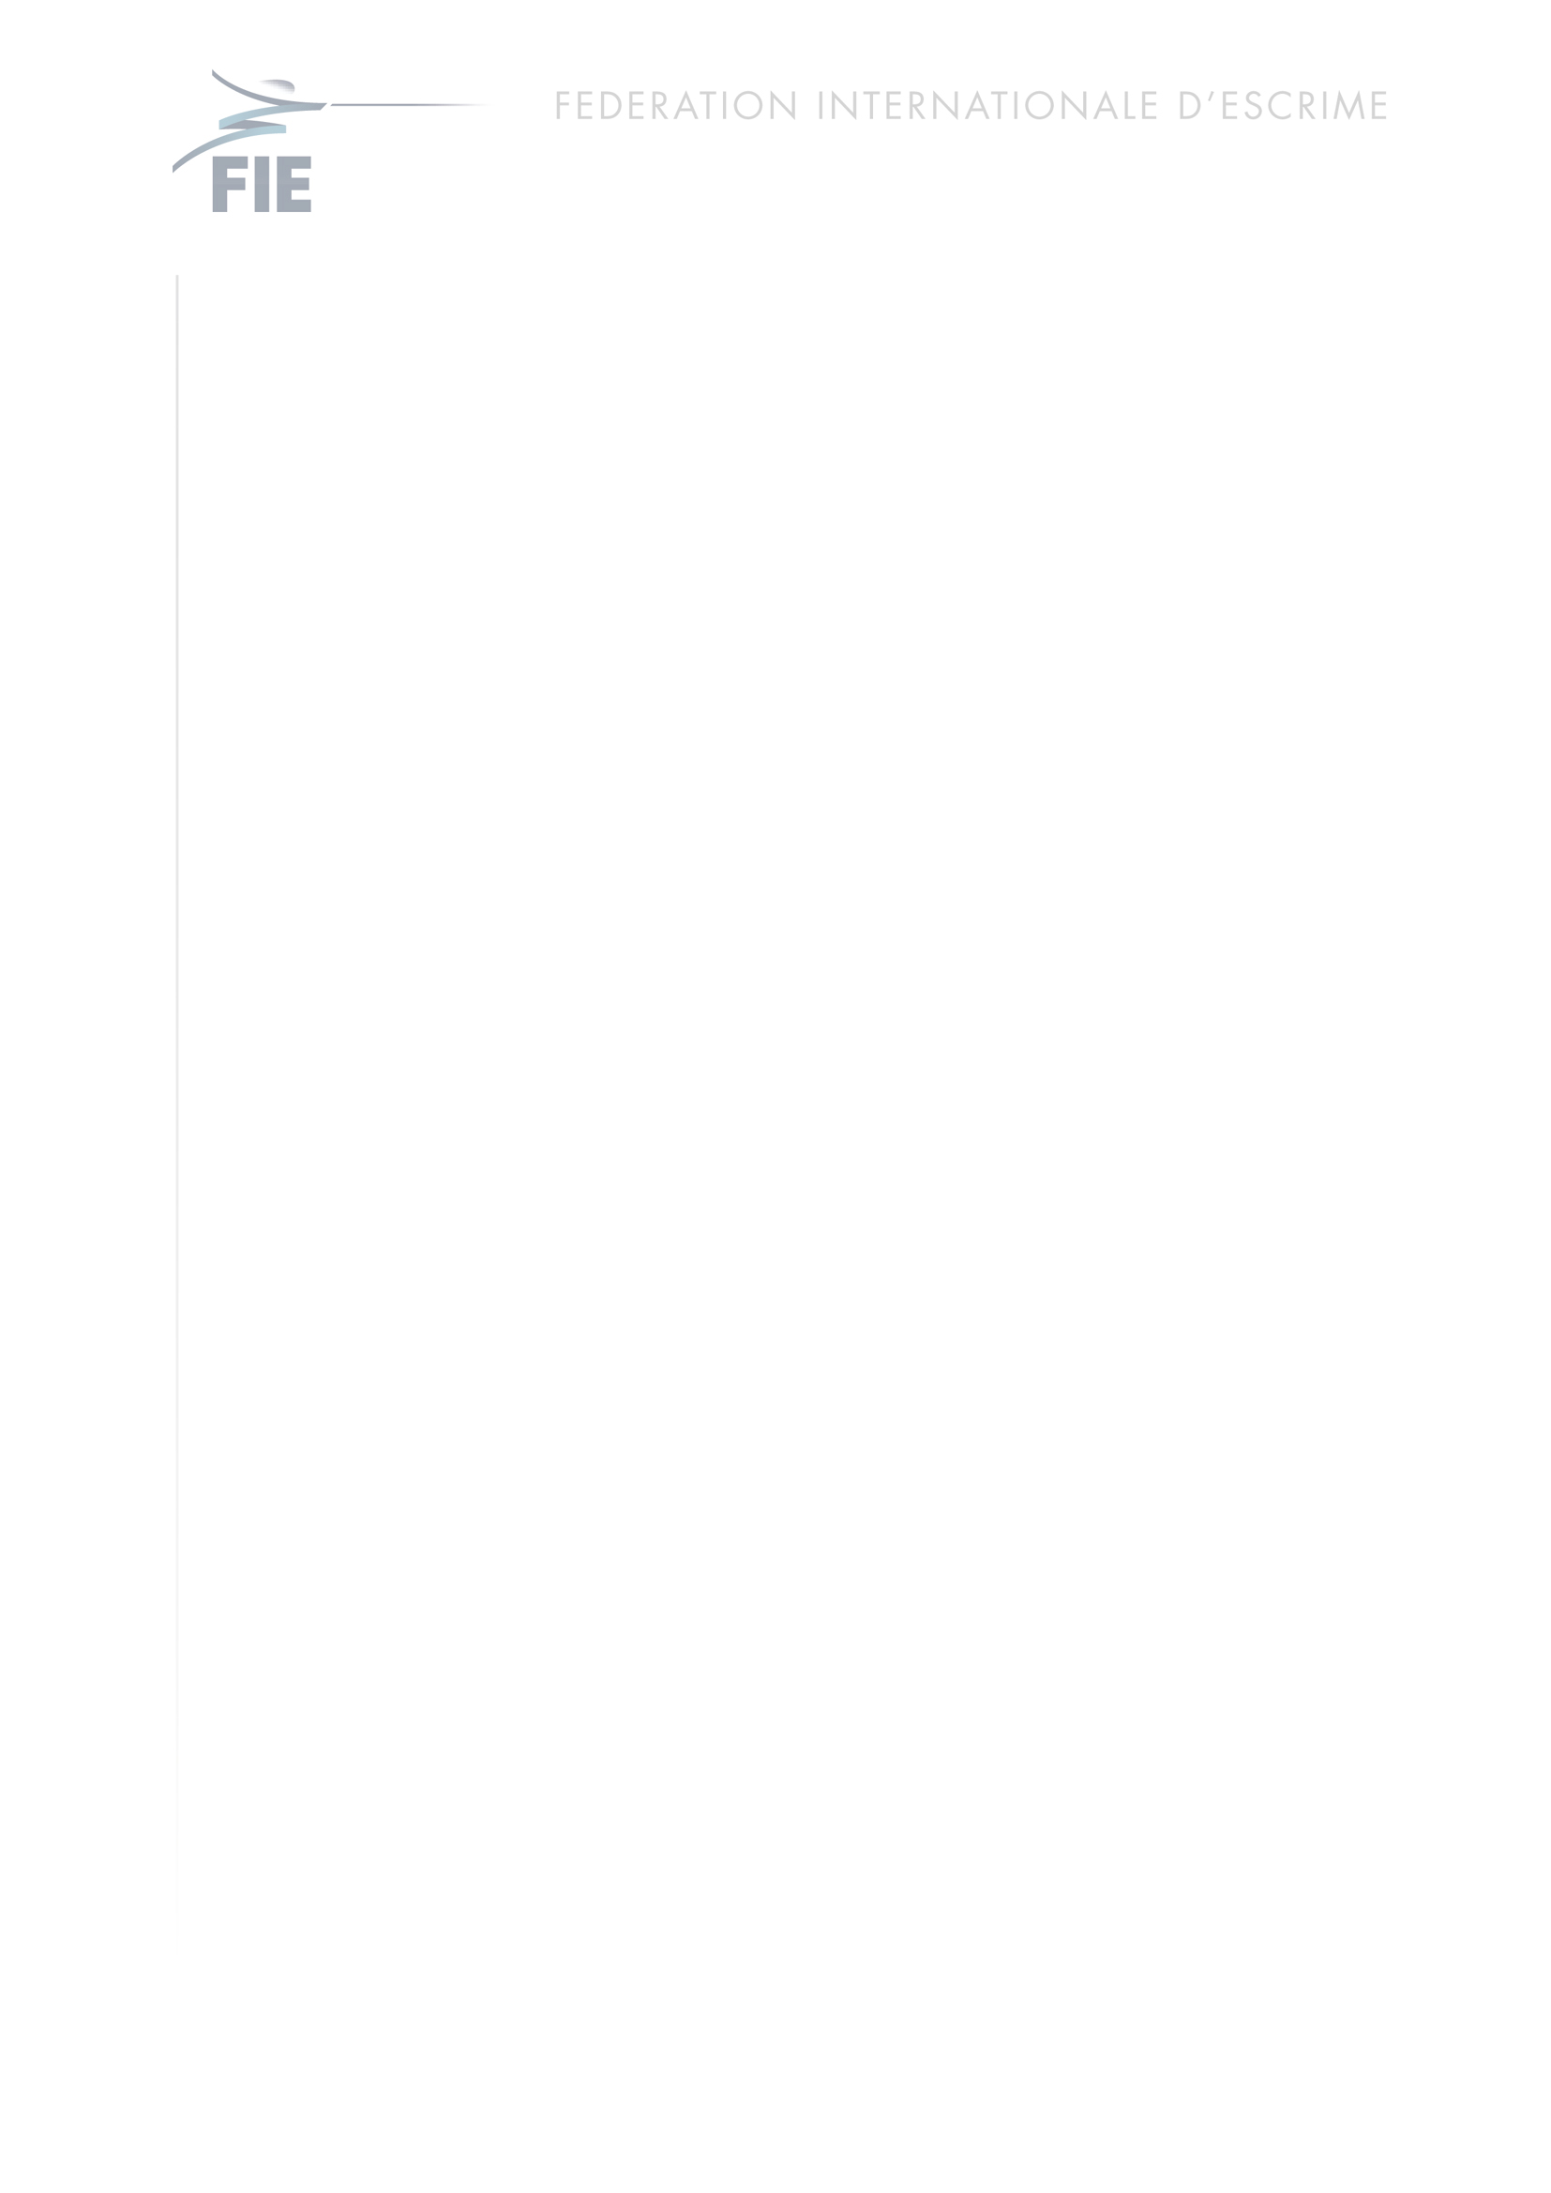

2016 FIE ACP – FIE FENCING ACADEMY
Budapest, April 5, 2016 – June 30, 2016
APPLICATION FORM

FAMILY NAME
NAME
FULL ADDRESS
PHONE
E-MAIL
DATE OF BIRTH
PLACE OF BIRTH
PASSPORT NO.
EXPIRY DATE
WEAPON
PARTICIPATION | Zonal Championship In 20_ _  World Championship In 20_ _

To be eligible for the FIE ACP, applicants must meet the following requirements:
● Being member of the National Team and participated in at least a Zonal Championship or a World Championship
● Language proficiency in English or French

Please send the present application form, a CV and copy of your passport to training.camp@fie.ch

Date | Signature

